1. We are only looking at the comments and not the replies to the comments, because the comments are about the trailer itself, but the replies are about the other people’s opinions.
2. Disaster Movie has this comment. Probably going to be ignored or marked as a neutral comment. Pre-processing should take care of emojis and some special characters in other comments.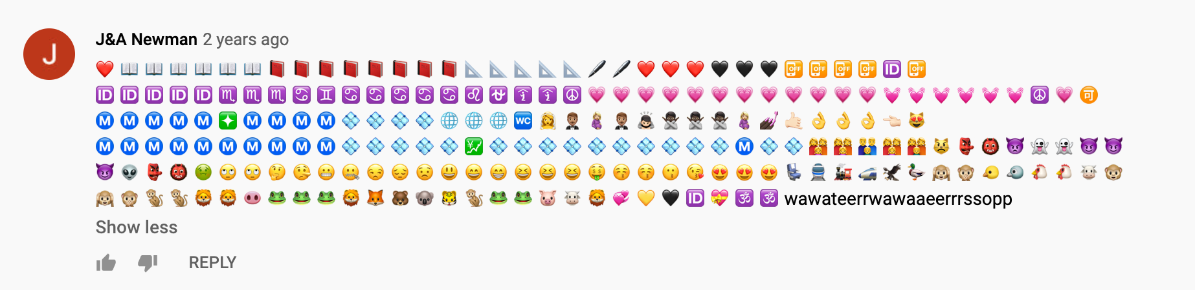
3. The movie Cats has too many comments. I tried mining the comments from it and it took at least 20 minutes and at least 9000 YouTube API calls (out of maximum 10000 daily calls). Then it gave an error ‘maximum number of calls reached’.
4. We can make dataframes with the csv files that contain all the comments. It looks like this: 